**Game Design Document**

**Title**

**Skunk Simulator**

**Game Genre**

Action, Simulation, Casual

**A game pitch document by:**

(Your name goes here.)

(Place a key piece of art that exemplifies the look, feel and tone of your game here.)

* **Define the desired game mechanic or feature. What are you making?**

The main idea behind the game mechanics was to create a game that allows you to have a good time without any pressure, something more relaxed that you can play to take a break or enjoy yourself for a while. The mechanic we used is “Spray,” a little skunk who wants to spray his scent on every human around him. We added limits to the spray to make it more dynamic and included a counter to keep track of how many humans you’ve sprayed.

* **Detail design rationale**. What kind of experience do you envision? How is it innovative or experimental?
* **Cite all resources, tangible, informative, and transformative**. Cite all resources used in planning and development including the basis project, assets, guides, tutorials, and use of generative AI (max 50% contribution overall to project).

**Resources**

**Environments**

* <https://assetstore.unity.com/packages/3d/environments/urban/city-package-107224>

**Skunk**

* <https://assetstore.unity.com/packages/3d/characters/animals/mammals/striped-skunk-29599>

**NPCs**

* <https://www.mixamo.com/#/>

**VFXS**

* <https://assetstore.unity.com/packages/vfx/particles/cartoon-fx-remaster-free-109565>

**UI**

* <https://www.freepik.com/>

Tutorials:

<https://www.youtube.com/watch?v=SAU5UTP53Ho>

<https://www.youtube.com/watch?v=MGGkQ3CJjBo>

**Logline**

(A logline is a one sentence summary of your game. E.g., *Portal*: a test subject wakes up in the ruins of an abandoned scientific testing facility. To escape, she must complete an increasingly devious series of puzzles delivered by a sadistic A.I.)

**Game Summary**

We drew inspiration from Goat Simulator and wanted to create a similar simulation style game but instead from the perspective of a skunk.

(An overview of your game. Who is the main character? What is their ultimate goal? What obstacles do they face? What is the setting? Who is the main antagonist? What makes your game unique?)

**Character**

Our main character is a small skunk with an adventurous and playful personality, but he sometimes feels lonely. For this reason, his goal is to walk around the city and spray his scent on every human he sees, so everyone will be like him, and he can have more friends.

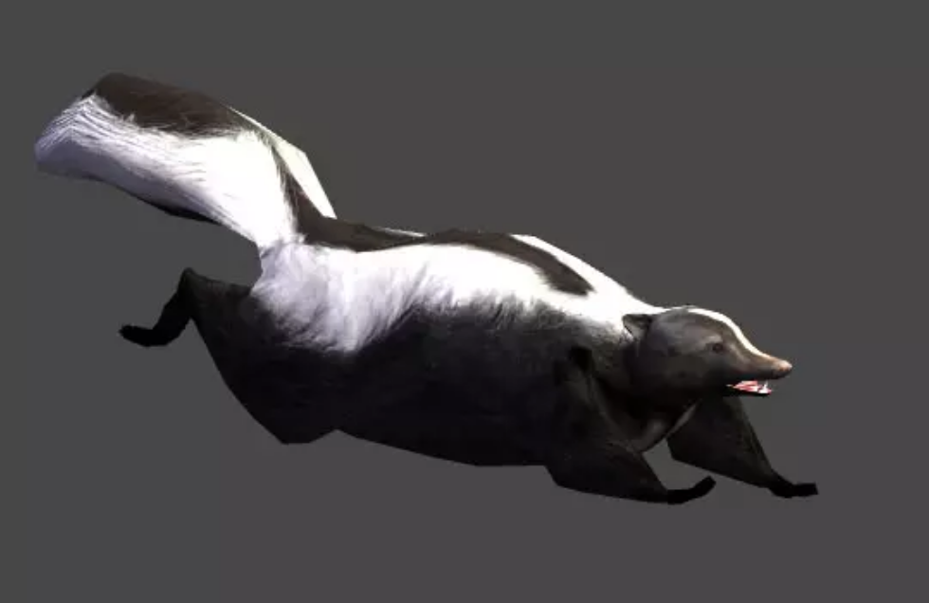

**The World**

The world in which the story takes place is a city called Stinkborough. It’s a small city with a lot of activity. It has tall buildings and parks where our main character can move freely wherever he wants.

We set the city in a modern time period, between the years 2020-2024, located in southern Canada. It has a warm climate and various types of NPC characters you can encounter due to the city’s cultural diversity. It’s a lively and cheerful city, with a typical day resembling what we see in our everyday lives, (including the constant scent of skunks in the air).

(Provide an overview of the world in which your game takes place, e.g. Hyrule from the *Legend of Zelda* games, or San Andreas from *GTA V.* Be sure to include all of the major aspects of your world, e.g. culture, geography, climate, magical system, level of technology, etc. Is your world contemporary, fantastical, science-fictional? How is it similar to, or different from our own world?)

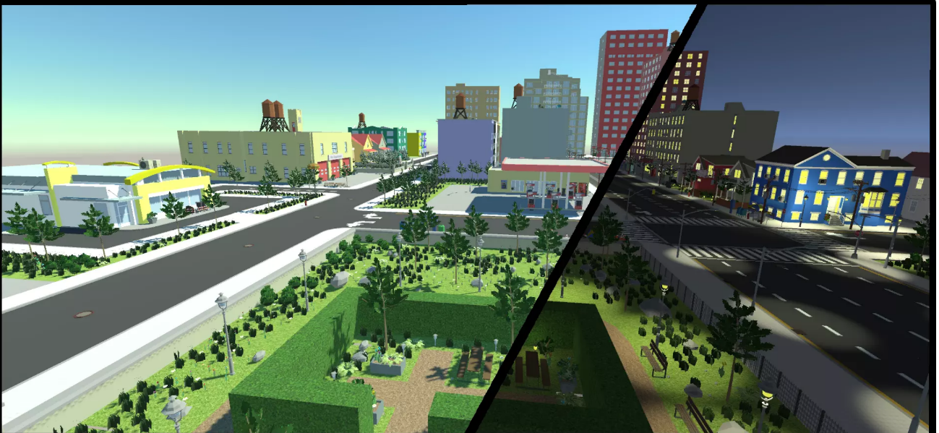

**Key Items or Concepts**

(In some games there are key items or concepts that help define the world, e.g. the Pip-Boy in the *Fallout* series, or The Force in the *Star Wars* universe, etc.)

(Place images that exemplify each item or concept here.)

**Gameplay**

(Briefly describe important gameplay elements here, e.g. the ‘Paragon / Renegade System’ in *Mass Effect2*, the procedurally generated weapons in the *Borderlands* games. Bullet points are fine, this is a creative document, not a technical brief.)

**Main Quest**

(Outline your main quest here, be sure to include all major objectives and story branches.)

**Side Quests**

(Outline your side quests here, be sure to include all major objectives, highlighting cases in which a side quest impacts your main quest.)